**ENGG100 LAB 5 REPORT**

**INSTRUCTIONS BEFORE SUBMISSION**

* Rename this report to Lab5_StudentID
* Make sure you add all the required screenshots/evidence for all the tasks
* Fill in the header information with your name, student ID & date
* Make sure to add one line to each task explaining what you have done for that task and what you have learnt

**TASK 1**

Write a script that asks a student for their marks and converts it into a grade:

* Between 85-100: “You have scored High Distinction (HD)”
* Between 75-84: “You have scored Distinction (D)”
* Between 65-74: “You have scored Credit (C)”
* Between 50-64: “You have scored Pass (P)”
* Less than 50: “You have Failed (F)”
* In your script, include an else statement that checks for incorrect entries (e.g. a negative number, number higher than 100) and displays an error to the user

TEST VALUES: -3, 25, 72, 83, 97, 130

|  |
| --- |
| **Screenshot evidence of code & results:** |
| **Explanation of task:** |

**TASK 2**

Create a for loop to display the below:

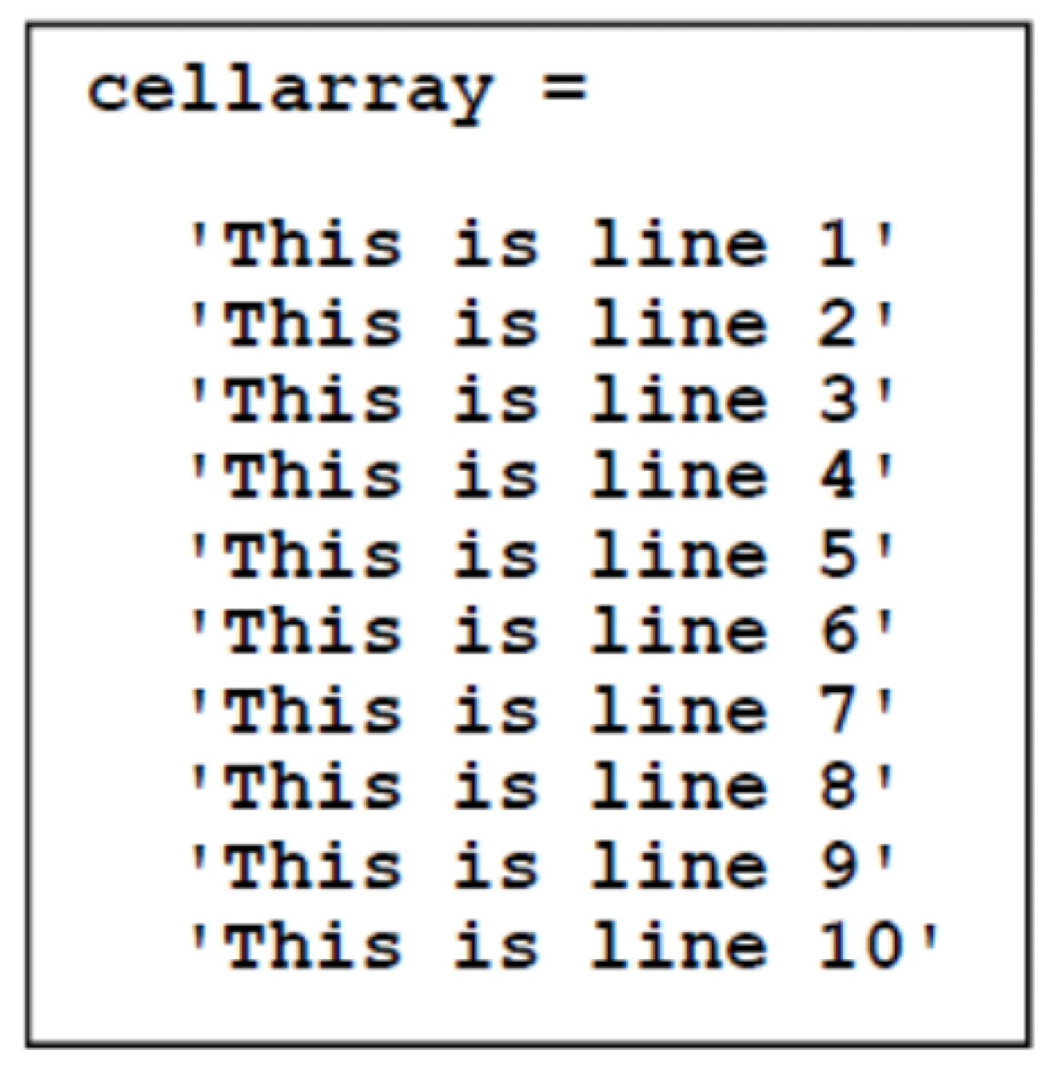

|  |
| --- |
| **Screenshot evidence of code & results:** |
| **Explanation of task:** |

**TASK 3**

A greyscale digital image can be defined as a two dimensional matrix containing 0’s (representing black) and 1’s (representing white)

* Create a 100x100 identity matrix and use imshow to plot a greyscale representation of the identity matrix (take a screenshot for your report)
* Next, use for loops and if statements to add to the identity matrix the following white lines:
* Add a horizontal line at rows 50 & 51
* Add a vertical line at columns 50 & 51
* Add a diagonal line from top right to bottom left

|  |
| --- |
| **Screenshot evidence of code & results:** |
| **Explanation of task:** |

__________________________________________________________

**TASK 4**

Use two nested for loops to create the following 2D array:

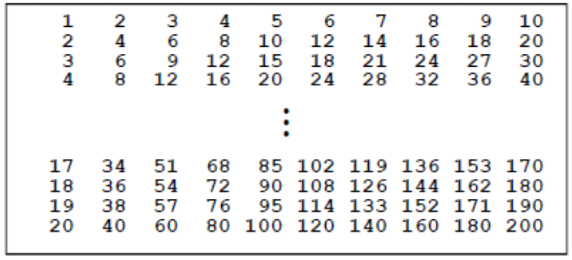

|  |
| --- |
| **Screenshot evidence of code & results:** |
| **Explanation of task:** |